Setting up SQL Server
- Ensure that the Microsoft SQL Server Express service is running, by accessing the SQL Server Configuration Manager. It can be found in
Start Menu\Programs\Microsoft SQL Server 2005\Configuration Tools\SQL Server Configuration Manager.
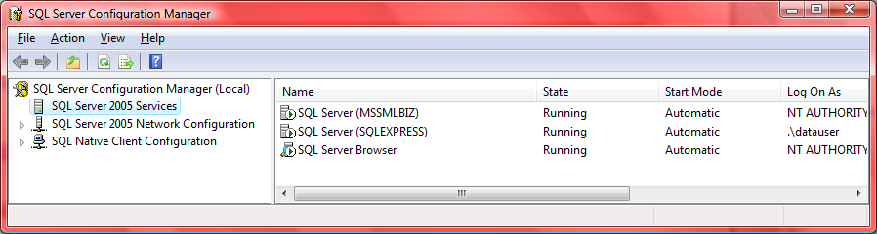
If this service is not available, download and install the server at http://www.microsoft.com/downloads/details.aspx?familyid=220549b5-0b07-4448-8848-dcc397514b41&displaylang=en.

Connecting to the SaleCo database
- For this assignment, Microsoft SQL Server Management Studio Express was used. Visit http://www.microsoft.com/downloads/details.aspx?FamilyID=c243a5ae-4bd1-4e3d-94b8-5a0f62bf7796&displaylang=en to download it.
- Open Start Menu\Programs\Microsoft SQL Server 2005\SQL Server Management Studio Express. Please remember to ensure that Microsoft SQL Server Management Studio Express runs as an Administrator.

- Connect to the SQL Server Database engine when prompted.
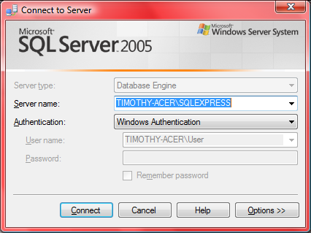
- In the Object Explorer, right click on Databases and select Attach...
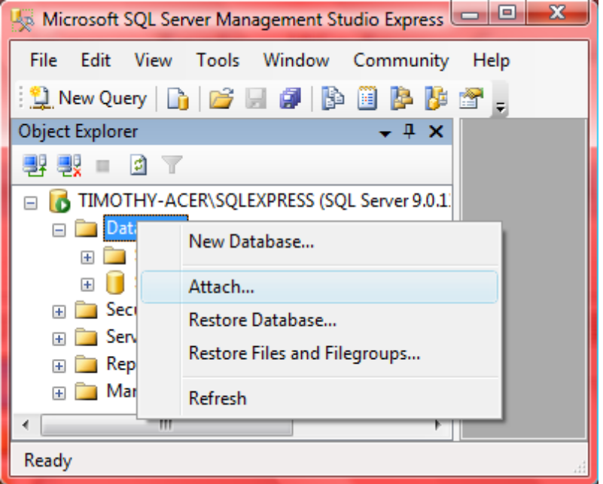

- Click on the Add... button and browse for the database file SaleCo.mdf. Please note that the accompanying log file SaleCo_log.ldf must be in the same directory as the database file. After adding the database, click OK.
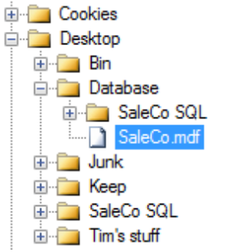
- SaleCo should now be listed in the Databases node in the Object Explorer.
- To load a SQL query click on  and browse for the .sql file. All queries are in the SaleCo SQL folder. Ensure that SaleCo is the selected database.
- Click  to run the query.

